Setup Procedure LMP3 – LMP4

Before Setup et setup patch preparation:

- Fuel in – 5KG
- Fit first the set of new tires on the car.
- Put the wight on carbon seat (70kg)
- Fit the steering straight on the car: check with digital gauge the level of the steering wheel.
- Check and put at the same level lateral patches and balance with the little aluminium bar. (First right one and after the left).
- When everything is parallel, fit the setup wheel and adjust to have the small support plate where the setup wheels fit at the center of the balance. (We need to move the patches +/- 13cm on the front and +/- 18cm on the rear).
- Check again that the patches are aligned and parallel (left and right).
- Please respect this process to build-up the setup patches.
- Fit front and rear squares, and toe line: check measurement from string to front of the wheel center (on setup wheel)
- Set the Spring Preload: contact + the required numbers of flats.

1-Damper Pre-load zero by mechanic
2-From theory: For LH circuits, +0.5mm RH side// For RH circuits, 1mm pre-load FR
3-FR pushrod +0.8mm longer than FL
900/2mm | 900/2.5mm
900/2mm | 900/2.5mm
4-Pre-load could be given to mechanics by flats & holes instead of mm

- Confirm with engineer that damper clicking has been done by him already.
- Confirm with engineer that the dampers gaps have been measured by him already.
Damper config. Baseline
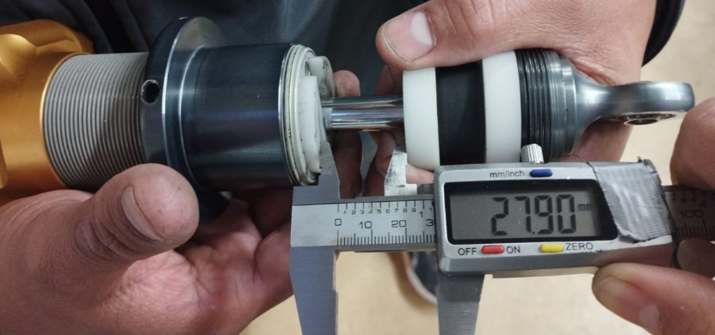
End eye/10/PKM/10/5o (27.90mm) All x4 dampers

- Disconnect anti-roll bars!

On the scales:

- When you take the car down on the scales, verify that nothing is moving, especially the metal plate support.
- Bounce front and rear at the same time (3 TIMES) front and rear syncronized.
- Get the corner weights within a delta of 10kg before going any further (reset balances)
- Check Ride Heights:
  - Bounce front and rear 3 times together.
  - Check Ride Height first on front with squares and measure push.
  - Adjust Ride Height close to setup sheet and be equal on both push lengths.
  - Remember for pushrods:
    - 1 flat on FRH is 0.5mm circa/1 flat on RRH is 1mm circa
  - Follow the engineer’s instructions!
- Check Camber (symmetric/asymmetric camber):
  - Put the digital gauge to the front of each setup wheel.
  - Confirm the value by reading it twice with the orange digital level: once screen to the front of the car, once screen to the rear of the car
- Check Toe:
  - Check and adjust the toe with the value on the setup wheel.
- Check the droops.
- Check Corner Weight (3 options)
  - Bounce front and rear 3 times together
  - If track is clockwise:
    - Bounce front and rear 3 times together
    - Adjust, if necessary, from the rear pushrod
    - Adjust the corner weight to have more weight on the right tires (+/- 8kg)
  - If track is anti-clockwise:
    - Bounce front and rear 3 times together
    - Adjust, if necessary, from the rear pushrod
    - Adjust the corner weight to have the same weight on the rear tires.
  - Third option:
    - Bounce front and rear 3 times together
    - Adjust from the rear pushrod
    - Adjust the corner weight to have more weight on one diagonal.

- Check again Ride Height and Camber
- Connect ARB’s
  - Connect first the FARB.
  - Then, connect the RARB (first left and after right), always make sure that the ARB links are free when connecting them otherwise the total weight on the wheels will be distorted
  - Check the corner weights again. They must remain as before

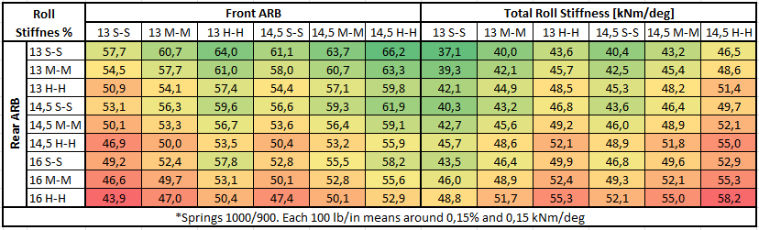

- LMP3: Check the 3th element packer gaps and set the gaps to the required values
- Zero sensors by the data engineer and ask him to measure the droops.
- Make sure the engineer is fitting the required open packers required for the desired static packer gap on the dampers
- Check that all the bolts from push, camber or toes are completely tight.

